Use-Case Realization Report
Update Lesson

Issue <2.0>
Revision History
Date | Issue | Description | Author
01/08/09 | 1.0 | Initial Version | Haiyang
16/09/09 | 2.0 | Revised after peer review | Haiyang

Table of Contents
1. Brief Description 4
2. Flow of Events 4
2.1 Standard Flow 4
2.2 Exception Flow 4
3. Interaction Diagrams 4
3.1 Collaboration Diagram for Update Lesson 4
4. Participating Objects 5
5. Class Diagrams 5
5.1 Class Diagram for Update Lesson 5
6. Derived Requirements 5

Use-Case Realization Report
Update Lesson

Brief Description

Flow of Events

Standard Flow
- Portal Admin clicks the “Update” button.
- Lesson controller will call Lesson Page to display itself.
- Portal Admin update the lesson content via Lesson Page.
- Lesson and relevant lesson sections will be updated.
- Lesson module will then be updated and marked the updated lesson.

Exception Flow
  - If the lesson to be updated conflicts with the existing lessons, e.g. trying to update the name of the lesson, but the name already exists in the database, then an error message will popup to remind the Portal Admin.

Interaction Diagrams

Collaboration Diagram for Update Lesson
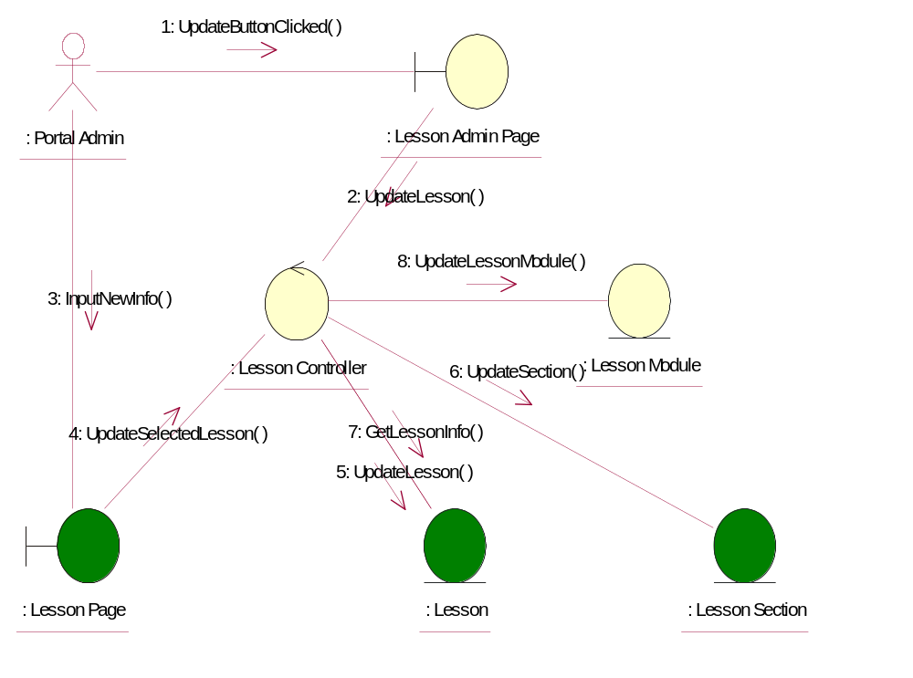

Participating Objects
: Lesson
This entity is the lesson object, it belongs to JMD.
: Lesson Admin Page
This is the page for adding, deleting, modifying lessons.
: Lesson Controller
This is the controller to upload, add, delete and modify lessons.
: Lesson Module
This is the object containing the lesson info.
: Lesson Page
Lesson Page is the one from JMD, which in charge of creating lessons.
: Lesson Section
This entity is the Section object, it belongs to JMD.
: Portal Admin
This is the super user of the system.

Class Diagrams

Class Diagram for Update Lesson
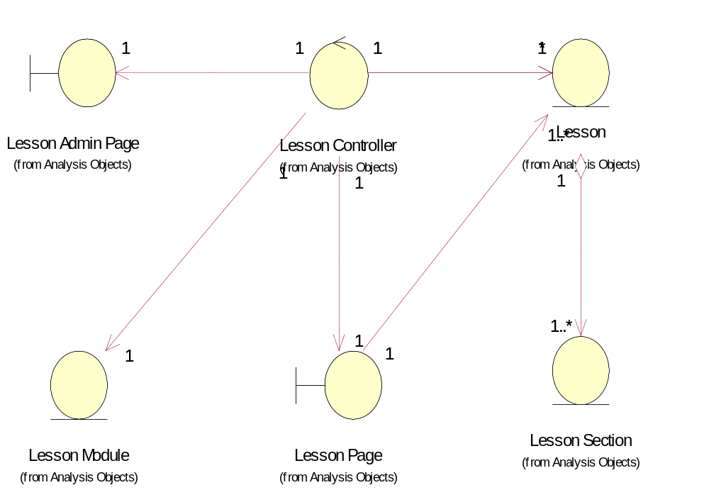

Derived Requirements
[enter the derived requirements here]

